SIMATS ENGINEERING
ASSESSMENT TOOL 1: Agent Design Assessment

COURSE NAME: ARTIFICIAL INTELLIGENCE COURSE CODE: MLA01 AND EXPERT SYSTEMS

COURSE OUTCOME COVERED

CO1: Apply search algorithms and heuristic techniques to solve state-space search and optimization problems. (BTL 3)

Assessment Tool Weightage: 55 %

Total Marks: 50 Time: 60 Mins
No. of Questions: 1
Annexure A
Agent Design Assessment

Code of Conduct:

I KANDALA CHANDANA (192525363) (Name / Reg No) certify that this submission is my original work and that I have adhered to the guidelines specified for this assessment. I understand that any violation of academic integrity rules will result in disciplinary action.

Signature of the student: Chandana

Question | Problem  Understanding  & AI Concept  Identification | Dialogue flow Agent  Design &  Implementation | Problem  Formulation  &  Conversation  Flow Design | Application of AI Techniques  & Reasoning | Testing,  Evaluation &  Documentation | Total
Weightage | 20% | 30% | 20% | 20% | 10% | 100%
Q1

Signature of the Faculty Total Marks Awarded

Scenario
A university wants to develop an AI-based Student Support Assistant to provide instant responses to student queries related to course registration, timetable, examination schedules, attendance details, and campus services.
As an AI developer, design and implement a conversational agent using Dialogue flow that can understand user requests, process intents, and provide appropriate responses.

Q. No. | Criteria to be evaluated | BL | Marks
1 | Problem Analysis and Agent Design: Analyze the student support problem and explain how Artificial Intelligence can solve the problem. Design the conversational agent by defining its objective, users, environment, inputs, outputs, and expected performance measures. | BL3 | 10
2 | Dialogue flow Agent Development: Create a Dialogue flow agent by designing appropriate Intents, Entities, Training Phrases, Responses, and Contexts. Explain how the agent perceives user queries and generates responses. Provide screenshots of the implementation. | BL5 | 10
3 | Problem Formulation and Decision Flow: Represent the chatbot interaction as a problem-solving process by defining the initial state, user goal, possible actions, state transitions, and goal completion conditions. Draw the conversation flow diagram. | BL6 | 10
4 | Search Strategy Application: Analyze how search techniques used in AI problem solving can support conversational agents. Apply a suitable search approach (such as Breadth First Search or heuristic-based search) to model intent selection or dialogue navigation and justify your choice. | BL5 | 10
5 | Testing and Evaluation: Test the Dialogue flow agent with different user queries. Evaluate accuracy, response quality, handling of unknown queries, and suggest improvements. | BL6 | 10

AI-Based Student Support Assistant

Dialogue flow Agent Design and Implementation for Course Registration, Timetable, Examination, Attendance & Campus Services

Assessment Tool 1 — Agent Design Assessment (Q2)

Scenario

A university aims to improve student support services by implementing an Artificial Intelligence (AI)-based conversational assistant. Students frequently require information regarding course registration, class timetables, examination schedules, attendance percentages, fee details, and various campus services. During admission periods and examination seasons, the number of student queries increases significantly, making it difficult for administrative staff to respond to every request quickly.

To solve this problem, the university plans to develop a Dialogue flow Conversational Agent capable of understanding natural language queries and providing instant, accurate, and intelligent responses. The chatbot uses Natural Language Processing (NLP), Intent Recognition, Entity Extraction, and Fulfillment Services to communicate with students efficiently. It is available 24 hours a day and helps reduce the workload of university staff while improving the overall student experience

1. Problem Analysis and Agent Design

1.1 Problem Analysis
Educational institutions serve thousands of students every semester. Students frequently require information about academic and administrative activities such as registration deadlines, examination timetables, attendance percentages, classroom schedules, fee payments, scholarship details, hostel accommodation, transportation services, and campus facilities. Most of these questions are repetitive and require immediate responses.
In a traditional support system, students depend on administrative offices or faculty members to obtain this information. During busy periods such as admissions, semester registration, and examinations, university staff receive hundreds of similar questions every day. Responding manually to every query consumes considerable time and resources, resulting in delays, long queues, communication gaps, and reduced productivity.
Students may also face inconvenience because administrative offices are available only during working hours. If a student needs urgent information during weekends, holidays, or late at night, assistance is generally unavailable. This affects the overall learning experience and creates unnecessary stress for students.
The existing manual support system also increases the chances of human error. Staff members may accidentally provide outdated information, misunderstand student questions, or overlook important requests. Such issues reduce the efficiency and reliability of student support services.
Therefore, universities require an intelligent automated system capable of understanding student questions, processing requests accurately, retrieving real-time information, and providing quick responses without human intervention. An AI-powered conversational agent addresses these challenges by offering continuous, accurate, and personalized support to students while reducing the workload on university staff.
Figure 1. Existing Student Support System
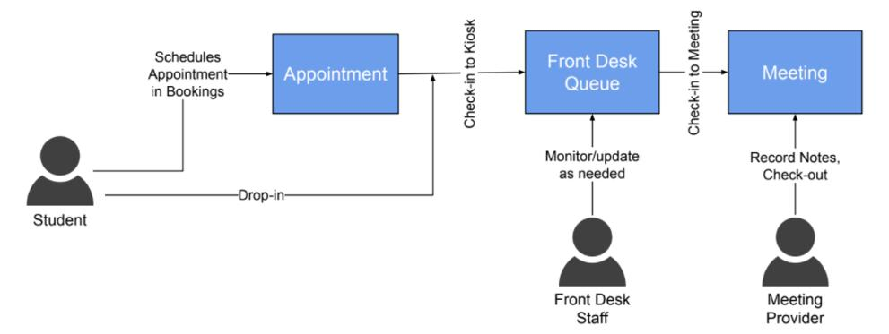
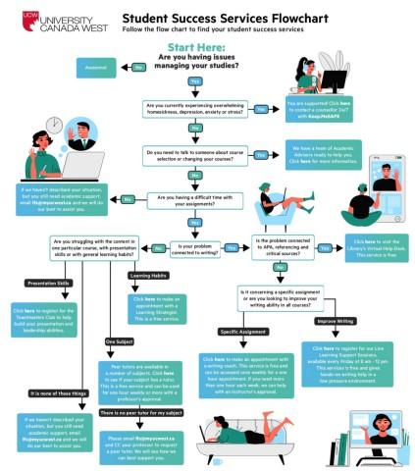
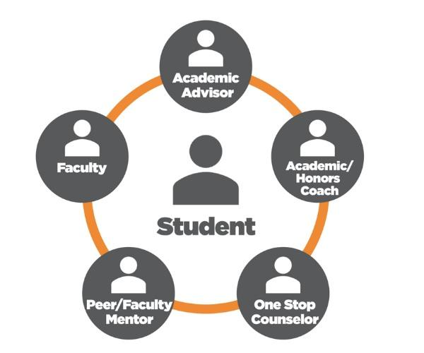

Figure 1 Description
The existing system shows that students must contact the administration office, wait for staff availability, submit requests manually, and then receive responses. This process becomes inefficient during peak academic periods due to the large number of student requests.

1.2 Role of Artificial Intelligence in Solving the Problem
Artificial Intelligence (AI) provides an efficient solution to the challenges faced in traditional student support systems. By integrating AI with Natural Language Processing (NLP) and Machine Learning (ML), the chatbot can understand human language, recognize user intentions, and provide meaningful responses within a few seconds. Unlike conventional systems that depend entirely on human operators, an AI-powered conversational agent can serve thousands of students simultaneously without reducing the quality of service.
The proposed AI-Based Student Support Assistant uses Google Dialogue flow as its conversational platform. Dialogue flow processes the student's question, identifies the appropriate intent, extracts important entities such as student ID, semester, course code, or department, and retrieves the required information from the university database using webhooks. This enables the chatbot to provide accurate and personalized responses in real time.
One of the major advantages of Artificial Intelligence is its ability to provide 24×7 support. Students no longer need to wait for office hours or administrative staff to become available. They can ask questions anytime and receive instant responses regarding attendance, examination schedules, fee payment status, course registration, or campus facilities.
Artificial Intelligence also improves the consistency and accuracy of responses. Since the chatbot retrieves information directly from authorized databases, the possibility of providing incorrect or outdated information is significantly reduced. Furthermore, AI continuously improves its performance through additional training phrases and conversation data, allowing the chatbot to understand different ways students ask similar questions.
Another important benefit is the reduction of administrative workload. University staff can focus on handling complex student issues while the chatbot manages routine and repetitive queries automatically. This improves institutional productivity and enhances the overall student experience.

Figure 2. AI-Based Student Support System
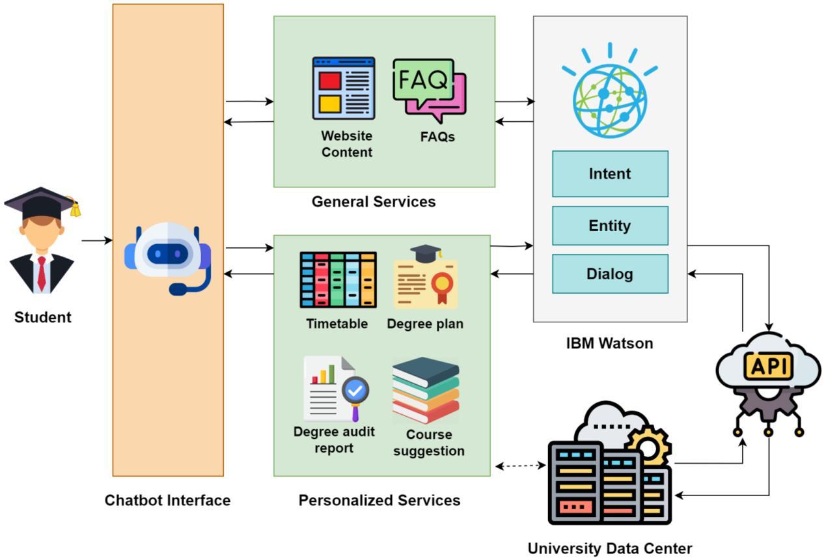
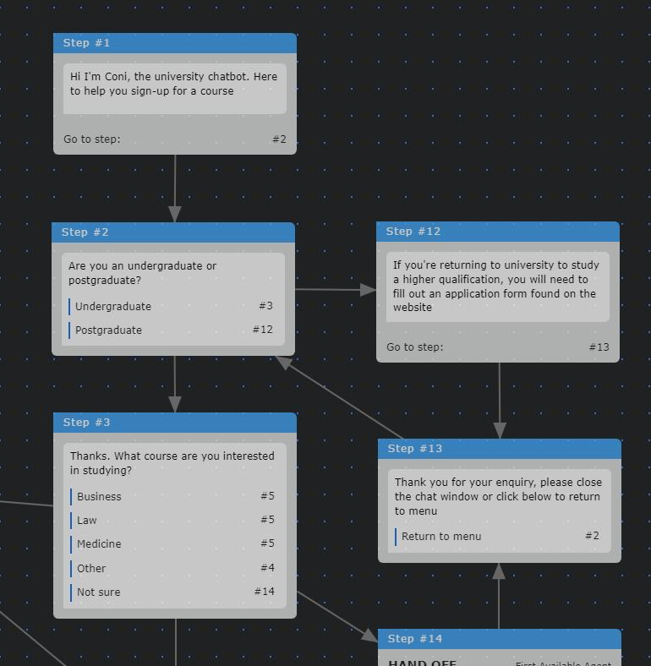
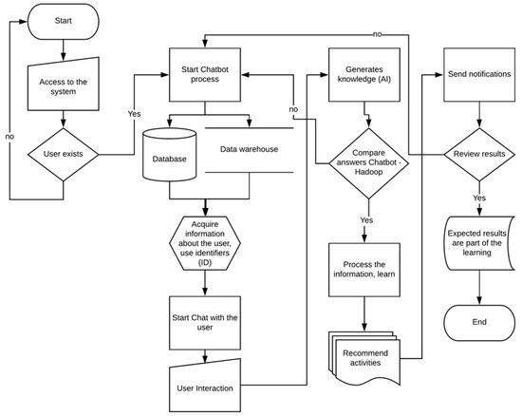
5
Figure 2 Description
The AI-based student support system begins when a student submits a query through a web or mobile application. The request is sent to Dialogue flow, where Natural Language Processing identifies the user's intent and extracts relevant entities. If additional information is required, the chatbot requests clarification from the student. The system then connects to the university database through a webhook, retrieves the necessary information, and sends an accurate response back to the student. This automated process reduces response time, minimizes manual effort, and improves service quality.

1.3 Agent Design
An intelligent conversational agent is designed to perform specific tasks by interacting with users through natural language. In this project, the agent acts as an AI-powered virtual assistant that helps students obtain academic and administrative information quickly and accurately. The design of the agent is based on clearly defined objectives, users, environment, inputs, outputs, and performance measures to ensure efficient operation.
Objective
The primary objective of the AI-Based Student Support Assistant is to provide instant, accurate, and intelligent responses to student queries related to course registration, examination schedules, attendance, timetables, fee payments, library services, hostel facilities, and other campus-related information. The chatbot aims to reduce administrative workload, improve communication, provide round-the-clock assistance, and enhance the overall student experience through automated support.
Users
The main users of the conversational agent include:
- Students
- Faculty Members
- Administrative Staff
- Examination Cell
- Admission Office
- Library Staff
Each user interacts with the chatbot according to their role and information requirements.
Environment
The conversational agent operates within the university's digital ecosystem. It is accessible through the university website, mobile application, or student portal. The chatbot communicates with Dialogue flow, web services, and the university database to retrieve real-time information. It functions continuously over the internet and supports multiple users simultaneously.
Inputs
The chatbot accepts user inputs in natural language. Typical inputs include:
- Student ID
- Department Name
- Semester Number
- Course Code
- Examination Name
- Attendance Request
- Fee Details
- Library Query
- Campus Service Request
Students may type questions such as:
- "What is my attendance percentage?"
- "When is my DBMS examination?"
- "Register my Semester 5 courses."
- "Show today's timetable."
Outputs
The conversational agent generates meaningful and accurate responses based on the user's request. After processing the student's query, the chatbot retrieves the required information from the university database and presents it in a simple and understandable format. The outputs are designed to help students obtain academic and administrative information instantly without requiring manual assistance.
Typical outputs generated by the AI-Based Student Support Assistant include:
- Course registration confirmation.
- Class timetable details.
- Examination schedule and examination hall information.
- Attendance percentage for individual subjects.
- Fee payment status and due dates.
- Library book availability and return dates.
- Hostel room allocation information.
- Scholarship application status.
- Campus event notifications.
- Contact details of university departments.
The chatbot can also provide hyperlinks to university resources, downloadable forms, academic regulations, and official announcements whenever required. If a student's query cannot be answered automatically, the chatbot politely redirects the request to the appropriate university department or administrative staff for further assistance.
The output is displayed immediately after processing the request, reducing waiting time and improving the overall user experience.

Expected Performance Measures
The effectiveness of the conversational agent is evaluated using several performance measures. These measures ensure that the chatbot delivers accurate, reliable, and efficient services to students.
1. Response Accuracy
The chatbot should correctly identify the student's intent and provide the appropriate response. Higher accuracy improves user confidence and reduces misunderstandings.
2. Response Time
The chatbot should generate responses within a few seconds after receiving a query. Fast response time increases user satisfaction and improves system efficiency.
3. User Satisfaction
The system should provide helpful, relevant, and easy-to-understand answers. Positive user feedback indicates successful chatbot performance.
4. Availability
The chatbot should remain operational 24 hours a day and 7 days a week, ensuring students can access support at any time without depending on office hours.
5. Scalability
The system should support thousands of users simultaneously during peak periods such as admissions, examinations, and course registration without affecting performance.
6. Reliability
The chatbot should consistently provide accurate information from authorized university databases with minimal errors or system failures.
7. Maintainability
The chatbot should be easy to update whenever new academic policies, examination schedules, courses, or campus services are introduced.
8. Security
The system must protect student information and ensure that only authorized users can access personal academic records through secure authentication and encrypted communication.

PEAS Representation of the Conversational Agent
PEAS Component | Description
Performance Measure | High accuracy, fast response time, user satisfaction, continuous availability, reliable information, secure access
Environment | University website, mobile application, student portal, Dialogue flow platform, university database, internet
Actuators | Chatbot text responses, notifications, confirmation messages, hyperlinks, downloadable documents
Sensors | Student text queries, student ID, course code, semester, department, user selections, database responses
The PEAS model clearly describes how the conversational agent interacts with its environment to achieve its objectives efficiently.

Figure 3. PEAS Model of AI-Based Student Support Assistant
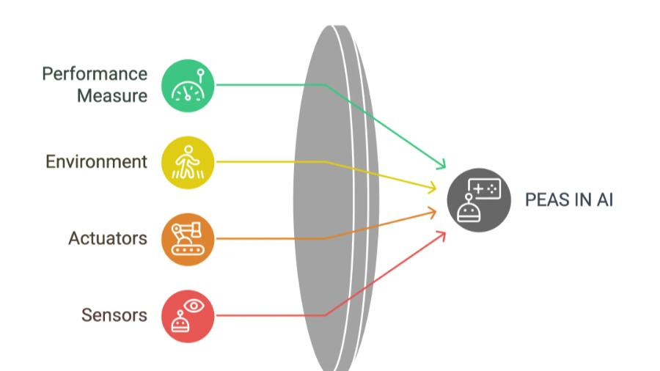
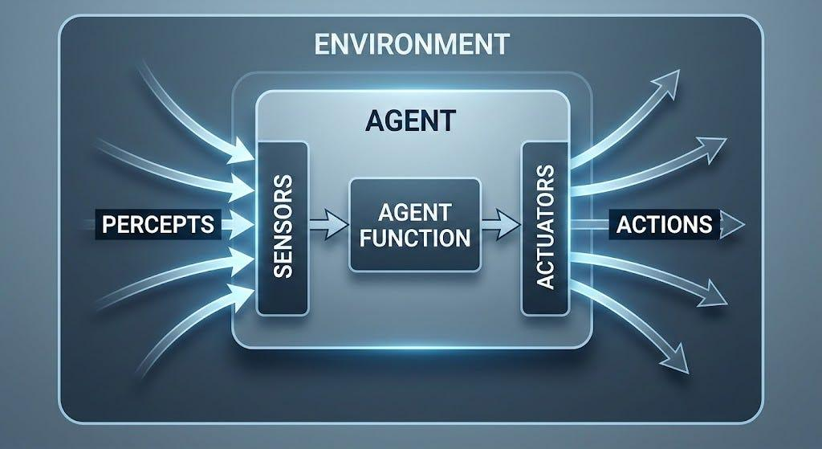
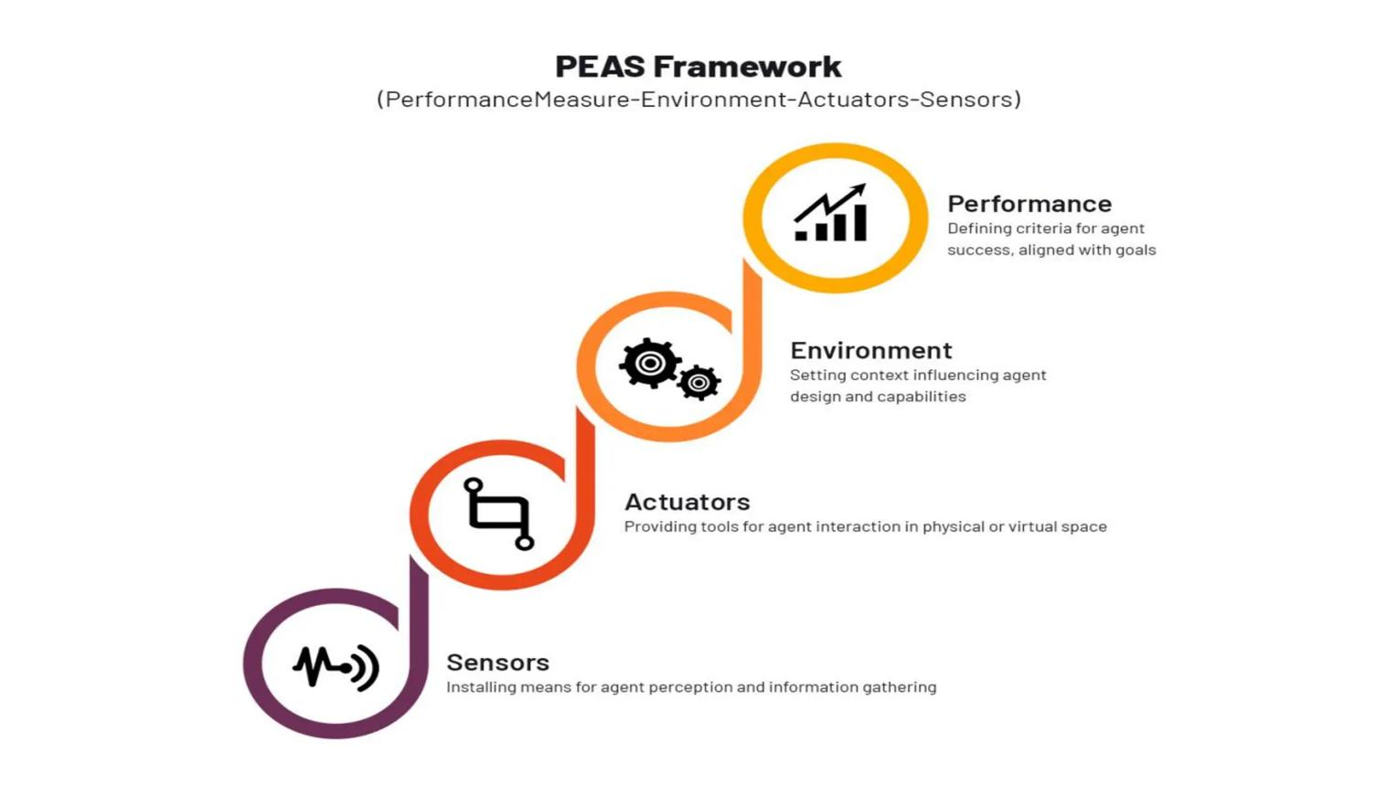
4
Figure 3 Description
The PEAS model illustrates the operational framework of the conversational agent. The chatbot measures its performance through response accuracy, speed, and user satisfaction. It operates within the university's digital environment, receives information through user inputs and database responses, and produces outputs such as chatbot replies, notifications, and confirmations. This model ensures efficient communication between students and university services.

Advantages of the Proposed Conversational Agent
The AI-Based Student Support Assistant offers several benefits to both students and the university. It provides instant responses to frequently asked questions, reduces administrative workload, improves communication, and increases the availability of student services. The chatbot operates continuously without interruptions, allowing students to receive support at any time. It also minimizes human errors by retrieving information directly from the university database. Additionally, the system can handle multiple users simultaneously, making it highly suitable for large educational institutions during busy academic periods.

Conclusion
The AI-Based Student Support Assistant provides an intelligent and efficient solution for managing student support services within a university. By utilizing Artificial Intelligence, Natural Language Processing, and Dialogue flow technology, the chatbot automates the handling of routine student queries while delivering accurate, timely, and personalized responses. The proposed conversational agent improves operational efficiency, reduces administrative burden, enhances communication, and increases student satisfaction through 24×7 support. Its well-defined objectives, users, environment, inputs, outputs, and performance measures make it a reliable and scalable solution for modern educational institutions. This intelligent system represents an important step toward digital transformation in higher education and demonstrates the practical application of Artificial Intelligence in academic environments.

